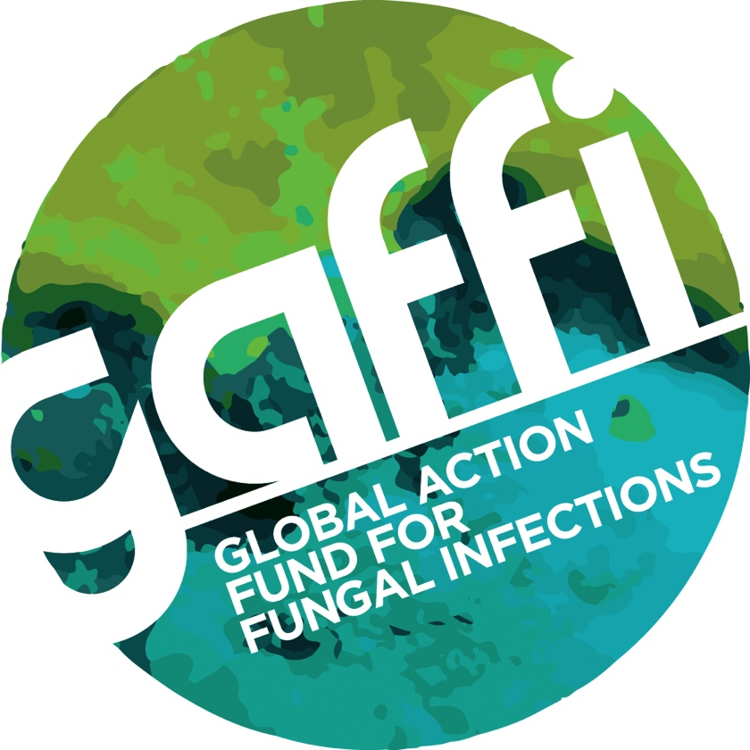

Embargo: GMT 23.01 Tuesday, October 14, 2014

FUNGAL DISEASE: THE ‘TROJAN HORSE’ THAT THREATENS THE WORLD AS DEATH TOLL RISES TO 150 PEOPLE EVERY HOUR

There’s a call for policy makers and health agencies to wake up to the plight of more than 300 million people worldwide who suffer and die every year from fungal disease.
It comes from GAFFI (Global Action Fund for Fungal Infections); an international organisation set up last year to highlight what doctors believe is a worldwide catastrophe that is growing year on year, yet could be halted with local access to diagnostics, antifungal medicines and better medical training.
Fungal infections kill at least 1,350,000 patients with or following AIDS, cancer, TB and asthma, as well as causing untold misery and blindness to tens of millions more worldwide. Yet, like a Trojan horse its symptoms are mostly hidden, and occur as a consequence of other health problems.
In the UK fungal infections affect around 10,000 people every year and while most patients survive, thanks to appropriate drugs and treatment, many suffer debilitating symptoms and long-term problems.
https://vimeo.com/107046272

Hollywood star and actor, Rupert Everett, has pledge to help GAFFI raise awareness among health professionals and the public. He says: “I understand from the experts that this is complicated and not straightforward. Only when it is too late is the diagnosis possible on clinical grounds, but even then many conditions overlap. The tragedy is that many of the best drugs have been with available in some countries for 40-50 years, yet not where they are now most needed.”

GAFFI’s founding President is Dr David Denning, Professor of Infectious Disease in Global Health at the University of Manchester. He explains: “Fungal disease is the Trojan horse – the silent, unappreciated global catastrophe on a scale no one has grasped until recently. For example, after TB as many as 20 per cent of patients develop lung fungal infection, which slowly progresses to death over five years, unless arrested with treatment, an estimated burden of 1.2 million people worldwide. Fungal meningitis and pneumonia kills in excess of 1 million patients with AIDS every year, including many children, before treatment for HIV can begin to work.

“Blindness caused by fungal infection of the eye affects over 1 million adults and children globally yet the tools are not available for rapid diagnosis and treatment for millions of people. Skin fungal infections affect a further billion people worldwide. Severe asthma with fungal allergy could account for half of the 350,000 deaths from asthma each year, yet it is treatable with antifungal drugs.”

In the last 12 months GAFFI has identified and estimated the burden of fungal disease in almost 40 countries, successfully lobbied the World Health Organisation to include two life-saving drugs on the Essential Medicines List and convinced the World Medical Association to address governments across the world to improve diagnostics and treatments of fungal disease.

For more information, or for images of the world maps that show the gaps in access to antifungal treatments in most countries, please contact Susan Osborne, Director of Communications at The Goodwork Organisation, on 07836 229208. www.gaffi.org

The video embed code for the short (2.06”) is: https://vimeo.com/107046272

There is a longer version (3’52”) here: https://vimeo.com/107802357

Please note the film is downloadable at broadcast quality and may be used without any restrictions.

GAFFI successes in the past 12 months are listed here:

- GAFFI has estimated the global burden of serious fungal infections for 59% of the world’s population including Argentina, Australia, Austria, Belgium, Brazil, China, Czech Republic, Denmark, Dominican Republic, France, Germany, Hungary, Guatemala, India, Iran, Iraq, Ireland, Israel, Jamaica, Kenya, Mexico, Mongolia, Netherlands, New Zealand, Nigeria, Russia, Saudi Arabia, Senegal, Singapore, South Korea, Spain, Sri Lanka, Tanzania, Trinidad and Tobago, Uganda, the UK, Ukraine, Uruguay, Vietnam and Zambia.
- Successfully lobbied the WHO to place amphotericin B and flucytosine on the Essential Medicines List to treat cryptococcal meningitis and other life-threatening fungal infections, in a coalition with other agencies including US Centers for Disease Control, attendees from LIFE, WHO, Medicines Sans Frontieres (MSF), Clinton Health Access and numerous universities and public health institutions.
- GAFFI has successfully lobbied the World Medical Association to adopt a statement addressed to governments on the need for improved access to diagnostics and treatments for fungal diseases, including the development of training for personnel in laboratories and for physicians. They also encouraged members to undertake and support epidemiological studies. [WMA statement].
- Advocacy has been initiated by GAFFI with the World Health Organization, UNAIDS, the Global Fund to fight AIDS, Tuberculosis and Malaria, MSF, and others. In particular, a combined burden and costing model for the diagnoses and management of cryptoccical meningitis is shortly to be handed to WHO, UNAIDS and Global Fund to facilitate countries accessing diagnostic testing and treatment for this lethal infection.
- GAFFI has developed a national ‘Fungal Diseases’ development plan for Kenya and another for China and one related to fungal diseases in AIDS for Guatemala.
- Prospective epidemiology studies of chronic pulmonary aspergillosis after TB, in HIV positive and negative patients, and smear negative TB ongoing northern Uganda (Gulu and Kampala), with GAFFI support.
- Supported the nascent cryptococcal disease access programme (CryptoMAG), a collaboration between the WHO (HIV Treatment and Care), CDC (Mycotic Diseases Branch), MSF (Access Campaign) Clinton Health Access Initiative and Management Sciences for Health (Technical Strategy and Quality Center for Pharmaceutical Management).
- Work has started at The University of Manchester on the fungal keratitis ‘eye drops’ to immediately visualise hyphae or yeasts cells in the eye.
- Development work on a simple and inexpensive method for DNA extraction from sputum for Pneumocystis diagnosis is nearing completion.

Professor David Denning FRCP FRCPath FMedSci
Director, National Aspergillosis Centre, University Hospital of South Manchester (Wythenshawe), Manchester, UK

David Denning is an infectious diseases clinician with expertise in fungal diseases. He is Director of the National Aspergillosis Centre, Manchester, UK which sees over 300 new patients annually with aspergillosis. He leads a multi-disciplinary research and clinical group, spanning fundamental genomics to randomised and phase 4 clinical trials in fungal diseases (infection and allergy). Major past contributions include describing azole resistance and mechanisms in Aspergillus, leading the effort to sequence the A. fumigatus genome (3 papers published in Nature), leading the phase 2 study and then RCT demonstrating the superiority of voriconazole over amphotericin B for invasive aspergillosis and describing and demonstrating antifungal efficacy in severe asthma with fungal sensitisation (SAFS). His current interests are chronic and allergic pulmonary fungal disease, the global burden of fungal infection and azole resistance in Aspergillus. He has published more than 450 papers, books and book chapters, including an undergraduate textbook of Medicine. He is heavily involved in postgraduate teaching, both clinical scientists and physicians. He was instrumental in the establishment of the Mycology Reference Centre in Manchester (2009), which grew out of the Fungal Testing Laboratory he founded in 1991. His work has been cited over 37,500 times (Google scholar H-index 93).

