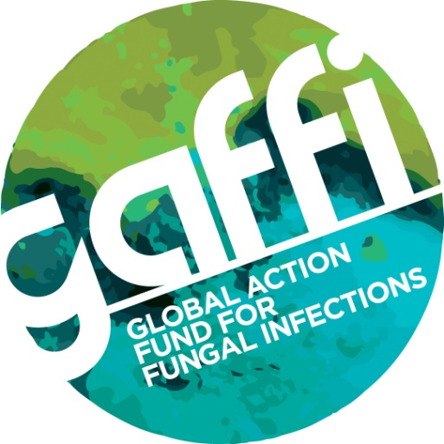

For immediate release

TENS OF THOUSANDS OF DEATHS IN INDIA COULD BE PREVENTED ACCORDING TO NEW STUDY

Experts from GAFFI (Global Fungal Infections for Fungal Infections) have declared an infectious diseases emergency in India after a new and disturbing report highlights tens of thousands of people diagnosed with life-threatening fungi or yeast in their blood.
In the first study of Candida bloodstream infection in 27 Intensive Care Units (ICU) in India, an incidence of 6.51 cases per 1,000 ICU admissions was seen, equating to ~90,000 cases nationally. Mortality varied from 35-75% with about 40,000 deaths. An estimated 14.3 million patients are admitted to ICUs in India each year.
The true burden of Candida bloodstream infection (candidemia) is larger as only ~33% occur in ICU. Therefore the population incidence in all hospital admissions in India is estimated to be 270,284 per year - equivalent to a population incidence of 21.1 per 100,000 people. This number is very high and approaching the incidence in the USA in 2012 (see Refs)). A dramatic rise in candidemia in adults over the last two decades was found in Atlanta, Maryland, Baltimore & Georgia.
In India, the authors report 1,400 ICU acquired candidemia cases, of which 65 per cent were adults. The 30-day crude and attributable mortality rates of candidemia patients were 44.7 and 19.6 per cent, respectively. Also a significant difference in the rate of candidemia survival in public sector compared to private hospitals was seen (Fig 1).

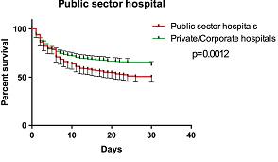

Professor Arunaloke Chakrabarti, the study’s lead author and Head of Medical Microbiology at the Postgraduate Institute of Medical Education and Research in Chandigarh (PGIMER) commented: " This is the largest study of acquired candidemia in India, and the high rates of candida bloodstream infections in our ICUs amounts to an infectious disease emergency. Some hospitals have low rates, others very high rates, which could reflect the case mix of patients or the medical abuse of antibiotics and poor infection control. Awareness of fungal infections among clinicians and competence of the laboratory to diagnose candidemia may also play some part on this variation of incidence. Action is urgently required on a national level to speed up diagnosis and prevent infection, if the huge numbers of deaths are to be reduced."
The study was published in the journal Intensive Care Medicine, and shows acquisition of candidemia occurred soon after admission - with a median occurrence at eight days. Patients with a low APACHE II score were also susceptible to acquiring this infection, with a median of 17 days following admission, when compared to studies from other countries such as Spain, USA and Argentina. In addition the mean age of the patients with candidaemia in Indian ICUs was lower at 49.7 yrs than in other countries (mean 59 - 66yrs).
A total of 31 different Candida species were identified including 41% with Candida tropicalis. Around 12% of the isolates exhibited fluconazole resistance. Also Candida rugosa and Candida auris were more predominant in public hospitals (than private ones): C. rugosa (5.6 % vs. 1.5 %; p = 0.001) and C. auris (8.2 % vs. 3.9 %; p = 0.008). Of note multidrug-resistant C. auris was isolated from 19 of 27 ICUs.
Blood culture is insensitive for invasive candidiasis, which is just as lethal as candidaemia, with blood culture only detecting ~ 40 % of all cases. ( See Refs Adjusting for this factor, the total caseload of invasive candidiasis in India is likely to be as 675,710 per year with an estimated mortality of 50% leading to 337,855 deaths.
For more information please contact Professor Chakrabarti on +91 172 2755173/2755155/2747990 or Fax: +91 172 2744401. Issued by Susan Osborne, Director of Communications, The Goodwork Organisation, telephone 079836 229208 or email susan.o@thisisgoodwork.org
References Link

