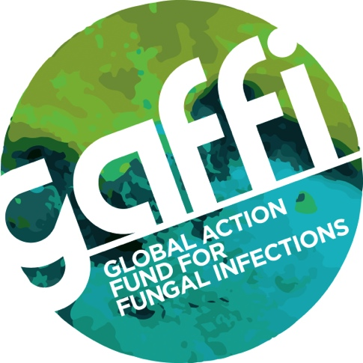
Embargo:
Sunday May 7, 2017 Midnight GMT

FUNGAL MENINGITIS STILL KILLING OVER 180,000 PEOPLE EACH YEAR DISPITE DRUGS AVAILABLE TO SAVE LIVES

International HIV experts on fungal meningitis in AIDS report finding nearly 250,000 cases annually, 73% in sub-Saharan Africa. Fungal meningitis due to the Cryptococcus fungus typically affects those in the prime of life, 35 years old, and affects the tissues covering the brain and spinal cord. Of those affected an estimated 181,000 people die, despite the existence of a simple blood test and long developed life saving medicines.

Deaths from Cryptococcal Meningitis in AIDS are 15% of all 1,100,000 AIDS-related deaths. Yet, the vast majority of those who survive do so without complications and with treatment of their HIV infection, go on to make a full recovery.

Published in the prestigious journal Lancet Infectious Diseases, Radha Rajasingham and colleagues from the University of Minnesota, which also runs a major research program on fungal meningitis in Kampala in Uganda, used 46 studies from around world to estimate current case numbers. The resurgence of interest in fungal meningitis arises from excellent diagnostic tests that take 10 minutes to perform and cost only about £5/$8. Patients can be picked up early with a blood test and treated. Without diagnosis and treatment fungal meningitis in AIDS is always fatal.

Dr David Boulware, Associate Professor of Infectious Diseases at the University of Minnesota, and senior author of the study, said: “Still too many HIV-infected people enter care late and Cryptococcal Meningitis is an unfortunate excellent metric of HIV treatment programme failure. In 2017, no person with HIV should develop fungal meningitis, yet in a failed cascade of HIV care, too often Cryptococcus is a final death sentence.”
The Global Action Fund for fungal Infections (GAFFI) with numerous other organisations persuaded the World Health Organization to place the key antifungal drugs for Cryptococci meningitis – amphotericin B and flucytosine – on the Essential Medicines List in 2013. However no African country has flucytosine routinely available in 2017. Several countries don’t have amphotericin B and the Global Fund has yet to provide any funding for these medicines.

Dr David Denning, President of GAFFI and Professor at the University of Manchester declared: “While Cryptococcal Meningitis numbers have fallen slightly with better HIV care, over 20 million people are not receiving anti-HIV therapy and in the meantime, too many are dying of completely treatable infections, when they first attend hospital with AIDS. Even when anti-HIV therapy is routinely available, cases still occur regularly, as demonstrated in Botswana.”

Link to Lancet ID article:

Notes to Editors:
For more information please contact Susan Osborne, Director of Communications, The Goodwork Organisation on 07836 229208.

GAFFI is a charitable foundation (NGO) focused on reducing deaths and illness caused by fungal disease.
Fungal diseases are neglected worldwide by public health authorities. GAFFI efforts are directed at:

1. Identifying and publicising gaps in diagnostics and treatments for fungal diseases
2. Consulting on how healthcare could be improved through facilitating training, encouraging companies to expand their markets and recommending improvements in infrastructure
3. Estimating the burden of serious fungal diseases, country by country. Over 68 country estimates are complete, and many of these are published
4. Developing, implementing and evaluating countrywide diagnostic programs - Guatemala (fungal infections in AIDS) the first
5. Influencing national and international agencies to ‘adopt’ fungal diseases alongside existing programs including TB, microbiology, AMR, NTDs and incorporation of key generic antifungals onto the WHO Essential Medicines List.
6. Focusing diagnostic improvements for GAFFI’s priority diseases.

GAFFI issued a 10-year Roadmap in 2015 calling for ‘95-95 by 2025’, summarized as 95 per cent of patients with serious fungal infections are diagnosed and treated. http://www.gaffi.org/roadmap/

http://www.gaffi.org/who-reinstates-amphotericin-b-and-flucytosine-on-the-essential-medicines-list/
http://www.gaffi.org/millions-deprived-of-life-saving-antifungal-medicines/
http://www.gaffi.org/cryptococcal-meningitis-persists-despite-90-90-90-botswana-experience/

