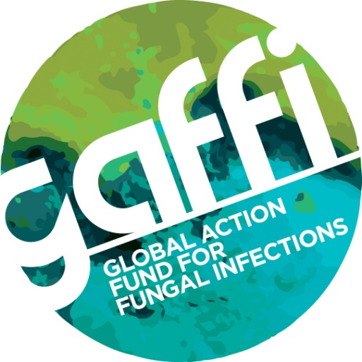

For immediate release

GAFFI LEADERS HIGHLIGHT INDIA’S PLIGHT AS FUNGAL INFECTION CAPITAL OF THE WORLD

Crucial talks took place yesterday (Tuesday) in Dehli to highlight the plight of millions of people in India who die needlessly of fungal infection because of poor diagnosis and treatment.

Leaders from GAFFI, the Global Action Fund for Fungal Infections, met India’s Health Minister following talks with country representatives of the WHO’s South East Asian Regional Office (SEARO) and the Indian Council for Medical Research (ICMR) to call for a network of testing laboratories across India and trained clinical staff to help reduce unnecessary deaths.

The delegation, which included GAFFI’s President, Professor David Denning and Professor Arunaloke Chakrabrti who runs India’s reference laboratory for fungal diseases, are hopeful of success. At the meeting, Health Minister JP Nadda declared: “ GAFFI’s bold attempt to define a clear pathway for improvements in care for patients with serious fungal disease is welcome. The Indian government is committed to improving healthcare for all its citizens and recognises that modest investment in this area will reap large health benefits.”

His comments were supported by Health Secretary Lov Varma and Additional Health Secretary CK Mishra.

Latest GAFFI statistics in India show the extent of the problem. For example:

- Fungal asthma (ABPA/SAFS) 1.5 million with ABPA (allergic bronchopulmonary aspergillosis, 1 million with SAFS (severe asthma with fungal sensitisation)
- Recurrent vaginal thrush in women – 23 million
- Chronic pulmonary aspergillosis after TB - 290,000
- Mucormycosis complicating diabetes and leukaemia – 170,000
- Fungal meningitis in AIDS (cryptococcal) – 18,400+

Professor Denning, who is Professor of Infectious Diseases in Global Health at the University of Manchester in the UK, says healthcare is improving in India and, as it does, the need for fungal diagnosis becomes even more acute. He explains: “There are too many unnecessary deaths because of inadequate testing capability and too much wasted antifungal therapy in hospitals on the wrong patients. There is a major need to build reference laboratories and train clinical staff – GAFFI’s focus is to get a mycology reference lab in each state, and surveillance reporting established in a network of labs across the country.”

Following talks with the Health Minister and Health Secretary, a follow up meeting was immediately convened by Dr Jagdish Prasad, Director General of the Health Service to discuss implementation with existing programs. Key public leaders of TB, non-communicable diseases and blindness programs agreed to develop national guidelines for chronic pulmonary aspergillosis with special reference to TB. All agreed that specific arrangements for future surveillance of fungal diseases, through a network of mycology laboratories, was seen as “highly desirable”. Reinforcing efforts to combat fungal keratitis was also discussed.

Professor Arunaloke Chakrabarti who is Head of Medical Microbiology at the Postgraduate Institute of Medical Education and Research in Chandigarh (PGIMER) adds: ‘Major strides in training in mycology are underway in India, but the provision of modern laboratories, funded to undertake diagnostics lags too far behind. Lack of diagnostics is hindering fungal outbreak control, reduction in risk for hospitalised patients, and causing excess expenditure on unnecessary treatments. Diabetes and asthma are rife in India and these lead to huge numbers of affected patients.’

Other meeting delegates included Prof BL Sherwal, Addl. Medical Superintendent (T) of Lady Hardinge Medical College & Associated Hospitals, New Delhi and Dr Shivaprakash M. Rudramurthy (Center of Advanced Research in Medical Mycology, WHO Collaborating Center for Reference & Research of Fungi of Medical Importance, PGIMER).

For more information contact Professor Chakrabarti on Phone: +91 172 2755155 or Professor Denning on mobile +44 7802 482193.

Issued by Susan Osborne, Director of Communications, The Goodwork Organisation. Email susan.0@thisisgoodwork.org or telephone +44 7836 229208.

Images/photos available on request or see www.GAFFI.org.

Notes to Editors
GAFFI is a registered International Foundation based in Geneva, focussed on 4 major tasks related to serious fungal infections. These are:
- Universal access to fungal disease diagnostics for serious fungal disease
- Universal access to generic antifungal agents
- Better data on the number and severity of fungal infections
- Health professional education related to better recognition and care for patients with serious fungal disease.

GAFFI was launched in India at the Indian Council for Medical Research (ICMR) on January 8, 2014. Blindness caused by fungal infection of the eye affects over 1 million adults and children globally with a particularly large number in India and SE Asia. Asthma is complicated by fungal allergy and is a key factor in severe asthma. In India there are 17-30 million adults with asthma. Asthma complicated by allergic aspergillosis is estimated to affect 860,000 to 1,520,000 in India (the highest rate in the world) and there are a similar number of patients with severe asthma with fungal sensitisation. Worldwide there are 350,000 deaths from asthma each year, many in India. Yet fungal asthma is treatable with antifungal drugs with 60-80% improvement rates. After TB about 20 per cent of patients develop lung fungal infection, which slowly progresses to death over several years, unless arrested with treatment, an estimated burden of 1.2 million people worldwide and 290,000 patients in India. Fungal meningitis and pneumonia kills in excess of 1 million patients with AIDS every year, including many children, before treatment for HIV can begin to work. Candida bloodstream infections are hospital acquired and India has one of the world’s highest rates with poor survival. Over 170,000 cases of mucormycosis are estimated to occur in India each year, the highest rate in the world.

