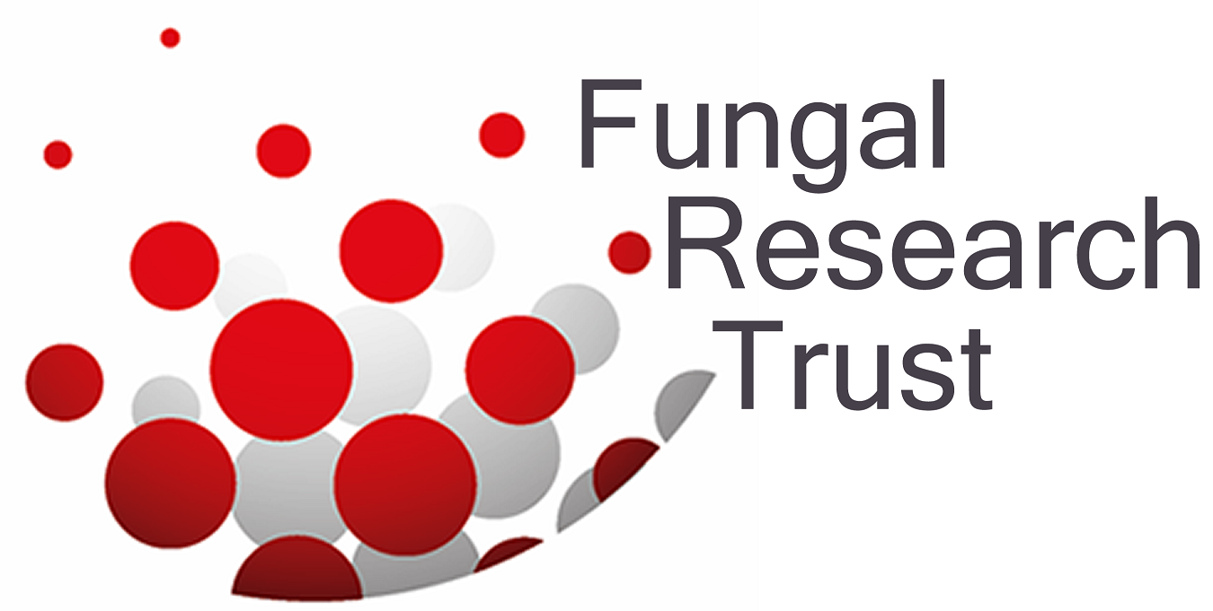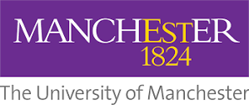

September 6th 2016. OO.01 BST

MANCHESTER FIRST AS e-LEARNING COURSE IN FUNGAL MICROSCOPY IS LAUNCHED WORLDWIDE TO HELP SAVE LIVES

Scientists estimate that of the 5 million fungus species on Earth around 600 cause disease in humans. It is a challenge to diagnose a serious fungal infection in real time and this course is aimed at teaching a rapid method of diagnosis.

Experts in Manchester have now developed the world’s first Fungal Microscopy online course. It is aimed at doctors, clinical scientists and laboratory technologists across the world, and because it is online students in poorer countries where the need for information is greatest will now be able to learn how to recognize most pathogenic fungi.

The number of people with expertise in fungal microscopy is at an historic low globally. Despite major technical developments in diagnostics and treatment the availability of rapid diagnostic methods is very poor in many parts of the world. This deficit contributes to the annual death toll of over 1,600,000 people from fungal disease each year.

The course will teach not only how to rapidly and accurately diagnose life-threatening fungal infections, but also how to set up direct microscopy in a diagnostic laboratory. It is available now at www.microfungi.net

Dr. David Denning, Professor of Infectious Disease in Global Health at The University of Manchester – and one of the course designers stated: ”The global prevalence of fungal diseases is increasing due to increases in susceptible patients (cancer therapies, organ transplantation, asthma, chronic lung diseases) and international travel. Very few diagnostics are as rapid as microscopy and it is inexpensive. Our course will enable any microbiologists and pathologists to rapidly diagnose most fungal infections in minutes, saving lives.”

The course was designed by Dr. Jenny Bartholomew, Michael Clarke, Prof David Denning, Dr. Riina Richardson, Dr. Emyr Benbow & Dr. Ruth Ashbee, with contributions from mycology experts globally.
Resources:
https://vimeo.com/176735942
Project LIFE competition (http://projectlifecompetition.org/resources)

ENDS

For more information, please contact Professor David Denning on +44 161 291 5811 or 5818 or visit www.microfungi.net or https://youtu.be/S5TQ3q9P3k0

Issued by Susan Osborne, Director of Communications, The Goodwork Organisation on 07836 229208

NOTES TO EDITORS

Experts at The University of Manchester and the Mycology Reference Centre, Manchester have developed the course. www.mycologymanchester.org
The Fungal Infection Trust (FIT) funds it, building on its outstanding track record in delivering online education resources for doctors, research scientists, students and patients. The FIT has contributed over £4 million to research and education over the past 20 years. http://fungalinfectiontrust.org/

The course comprises 4 modules:

- Basic microscope handling, sample preparation, safety and preparation of stains
- Identification of different fungi by direct microscopy
- Histology of the top 10 most common fungal infections
- Fungal histology of unusual fungi.

The course includes knowledge assessments, tests, quizzes and practice assessments. Participants who pass the final assessment are awarded a certificate of completion accredited by The University of Manchester. The FIT is grateful to Gilead Sciences Europe for their educational grant to support the second phase of the course’s development.

